STRATEGIC SUSTAINABILITY & RISK MANAGEMENT (ss&rm)
Ian R. Kirkwood. July 2012

Over the last decade or so, many sustainability and risk management frameworks have been developed to incorporate concepts in business, social justice, governance, and political systems. This document looks at the development of sustainability from the perspectives of ERM (enterprise risk management), TBL (triple bottom line), CSR (corporate social responsibility) and SE (sustainable enterprise) to develop a workable business model that is realistic and easy to implement.

Most sustainability theories have included elements of the following five issues in their models ….

1. Economic – The ability of an enterprise to survive and thrive through operations that fully internalize all costs (including ecological costs), and plan for and provide responses for both predictable and unpredictable future events. Economic performance includes prudent financial planning and the use of appropriate risk management systems to assure the continued ability to operate profitably. A sustainable business is also transparent in its operations with respect to the stakeholders it serves, its employees, and the communities in which it operates and sells its goods and services.

2. Environmental – The ability to produce goods and services with a net zero ecological impact. Environmental performance includes using processes and systems that are non-polluting, conserving of energy and natural resources (especially those that are non-renewable), economically efficient, safe and healthful for workers, communities & consumers. Sustainable manufacturers implement pollution prevention practices, use recycled and non-toxic input materials wherever possible and produce safe and recyclable products in recyclable packaging.

3. Social – The incorporation of principles that assure opportunities for full participation of stakeholders in all activities, benefits and decision-making. Social performance includes a philosophy that values human and natural capital and seeks to tap widespread resource productivity improvements coupled with effective design to allow more people to enjoy satisfying employment and financial well being measured in terms of security and social contact rather than consumption.

4. Operational – The incorporation of efficiencies and effectiveness in the structure and activities of an entity so that other objectives are achievable. Operational performance includes systems to monitor and measure activities and outputs to provide the feedback necessary for continuous improvement. It also includes communications that assure internal knowledge of performance and external harmony with stakeholders, customers and communities.

5. Strategic – The adoption of business strategies and activities that meet the needs of the enterprise and its stakeholders today while protecting, sustaining and enhancing the human and environmental factors that will be needed to assure continuing future performance.

Strategic performance includes selection and concentration on products that meet the current and future needs of a broad array of customers. It also involves decisions with respect to where manufacturing or other operations will be conducted, where products will be marketed, suppliers that can meet current and future needs and contractors that provide cost-effective equipment and services. Hiring management that understands and embraces corporate values, and provides leadership and vision that inspires performance and investor confidence is also part of strategic performance.

The Starting Point
Implementation of a sustainability program starts with an understanding of corporate principles and values. The fundamental values that unify an entity’s actions are a way of thinking about the work and the people that are derived from where the company has been, where it is today and its quest to continue delivering value into the future. Principles remain unchanged even though the enterprise itself may undergo substantial change over time. The values associated with the corporate principles flow through every aspect of the entity, providing the energy to drive sustainable performance.

The Triple Bottom Line (TBL)

The heart of sustainability is a fundamental immutable value set that involves parallel care and respect for ecosystems, for humanity, and for overall economic performance. The result against which success is measured is the achievement of human and ecosystem well-being through sound corporate governance. In order to succeed and to provide shareholder, employee and community value through sustained economic performance, as well as corporate financial performance, an entity must be able to recognize and respond to risks: risks that are known, unknown, and possibly unknowable. Traditionally, risks have been considered
mostly from a negative point of view – that is, risks caused losses and losses were charged against earnings to the extent they were available or against assets when earnings were inadequate. There is, however, a positive aspect to risks. Risks are a part of every undertaking of a business enterprise. The desire to take risk and the ability to understand it are fundamental drivers behind our global economy. Without it, no one would make investments or take the initiatives required to be successful. Several aspects of risk must be evaluated as an integral part of a sustainability process. This includes identification, analysis and management
of risks that affect current operations. It also includes paying attention to changes in the corporation, changes in the environment in which the entity exists and changes in the world that may directly or indirectly impact future success. With respect to new opportunities, businesses must be able to identify, analyze and address risks associated with new ventures. Lastly, the risk management program must be expanded to address emerging sustainability risks such as social and environmental risks, some of which may not be fully evolved or capable of measurement in the same sense that we normally evaluate traditional risks.

The Evolution of ERM into SS&RM
Strategic Sustainability & Risk Management Vs Enterprise Risk Management

Unlike sustainability objectives which include social and environmental considerations, Enterprise Risk Management’s (ERM ) typical program starts with the establishment of corporate objectives in strategic, operational, reporting and compliance areas. The diagram below (Figure 1) represents the traditional perspective on risk.

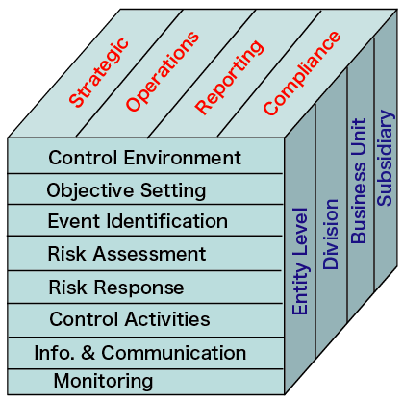

Fig 1: Typical ERM Framework

An example of traditional enterprise risk is the ERM Integrated Framework developed by the Committee of Sponsoring Organizations (COSO) and supported by the Institute of Internal Auditors. The COSO Framework contemplates eight interrelated components derived from the way management runs an enterprise. These are:

• Control (Internal) Environment – Encompasses the tone of the organization and sets the basis for how risk is reviewed and addressed. In sustainability models, this factor is the set of principles or values that guides corporate decision-making and flows through the organization to motivate performance. In the ERM model, this step involves the development of a risk management strategy and determination of risk appetite.

• Objective Setting – Assures that the corporation has a process to set objectives and that the chosen objectives support and align with the entity’s mission and are consistent with its risk appetite. In the sustainability model, this component would refer to strategic factors.
• Event Identification – Identification of internal and external events that affect achievement of objectives. Some events are risks and others represent opportunities. In sustainability models, this step is part of economic performance. Identifying opportunities might also be part of strategic performance, whereby the entity selects products, manufacturing bases and markets for its goods and services.

• Risk Assessment – Considers the
likelihood and impact of risks as a basis

for determining how they should be managed and what resources may be required. In the sustainability model, risk assessment is part of strategic and economic performance.

• Risk Response – Selection of a set of risk responses to align risks with the entity’s risk tolerance and appetite. This is also part of strategic performance as well as economic performance in a sustainability program.

• Control Activities – Implementation of policies and procedures to assure that risk responses are effectively carried out. In a sustainability model, control activities typically fall within operational performance.

• Information and Communication – Identifying, capturing and communicating relevant information in a form and in a timeframe that enable people to carry out their responsibilities. This is also part of operational performance in a sustainability program.

• Monitoring – Ongoing management activities and independent evaluations are used to monitor and adapt the program as changes occur. In a sustainability model, monitoring and constant feedback are part of operational performance, with the information developed being applied to economic, environmental, social and strategic performance as well. Where components of an ERM program are not fully evolved, the entity may have to substitute less sophisticated tools to make risk management decisions. This should not discourage risk managers from working towards a more comprehensive understanding of its risks and better decision making tools that are the ultimate objectives of ERM.

The principles discussed above also apply to the evaluation of risks associated with new businesses. The team working to develop the opportunity must include event identification as it relates to the new product, new acquisition, new market or other proposed change in operations. This may require considerable research and the use of independent consultants where the situation includes complex decisions. The evaluation of the risks in
such cases is an integral part of
anticipating the opportunity. The risk
management process should include the risk responses necessary to mitigate those risks that threaten success.
Optimization of Risks

Every business has a desire to increase profits and improve cash flows. The question is whether this can be done while implementing a sustainability program. In the Sustainability Handbook, William Blackburn makes the case for sustainability in a corporate environment where profit and cash flow are drivers. Clearly, a boycott of a company’s goods and services arising from social or environmental issues could have a far greater negative impact on a company’s bottom line than a natural disaster. He lists seven factors that support his assertion that sustainability is completely compatible with these objectives that include the following:

• Reputation and Brand Strength – Sustainable performance is one of the strongest determinants of corporate reputation, which has a significant effect on sales and stock price. Studies show more than 25% of a company’s public reputation is based on social
and environmental performance.

• Competitive, Effective and Desirable Products and Services – Companies can spur innovation by incorporating sustainability in their design process. By coupling a thoughtful design process with a detailed market analysis, a company can better address customer needs, produce competitive goods and services and access new markets.

• Productivity – Many aspects of sustainability, if properly addressed, can help improve business efficiency which boosts profits. Productivity includes reduced material requirements, reduced energy for production, reducing the use of toxic chemicals, improving recyclable-ability, improving the durability and reliability of products, and maximizing the use of renewable resources.

• Operational Burden and Interference Ignoring sustainability concerns can lead to public distrust, greater regulatory scrutiny, operational burden and cost. Public distrust of large corporations has become common in recent years and may lead to negative customer reaction as well as regulatory attention. The time and effort to respond to regulatory inquiries can distract senior management attention from core corporate objectives.

• Supply Chain Costs – By working on sustainability issues with suppliers and contractors, a company can help assure that critical supplies and services will be available and that costs will be controlled. It is becoming more common for companies to require that their suppliers meet minimum requirements for sustainable performance. For example, a builders’ supply company may require commitments of suppliers to provide only forest products harvested under sustainable growing programs (eliminating mature woodlands). For retailers, the commitments required of suppliers may include compliance with minimum wage and working condition standards.

• Cost of Capital – A growing number of investors and lenders are basing their investment and lending decisions on an evaluation of social and environmental performance as well as economic results. Published indexes rate the sustainable performance of corporations and provide investors access to information that allows them to invest in high performing entities.

• Legal Liability – Companies guided by sustainability principles are less likely to incur crippling legal liabilities which can affect the bottom line. This is especially true for claims arising out of environmental incidents and unfair employment practices that may be unusually severe and are sometimes difficult to insure. These issues can also result in claims against managers and directors for breaches of their duty in performing tasks related to corporate governance.

Implementing Value Adding Sustainability Solutions

A strategic business sustainability platform (SSRM) is a different way of looking at risk within an organization that incorporates the additional risk factors of environmental and social performance into the analysis normally employed in an ERM program. While it can build on past efforts that have implemented ERM and/or sustainability programs, it can also operate where neither of these programs has been adopted as formal corporate efforts. In such cases, it uses existing information and develops the additional data required to perform a risk analysis and develop response alternatives that are appropriate in light of corporate values and are aimed at achieving objectives that provide sustainable eco-structure and human solutions.

The SSRM sustainability platform assures a comprehensive assessment of five core objectives, the design and implementation of programs to address sustainability risks associated with those objectives, and the ongoing monitoring and management of those risks.

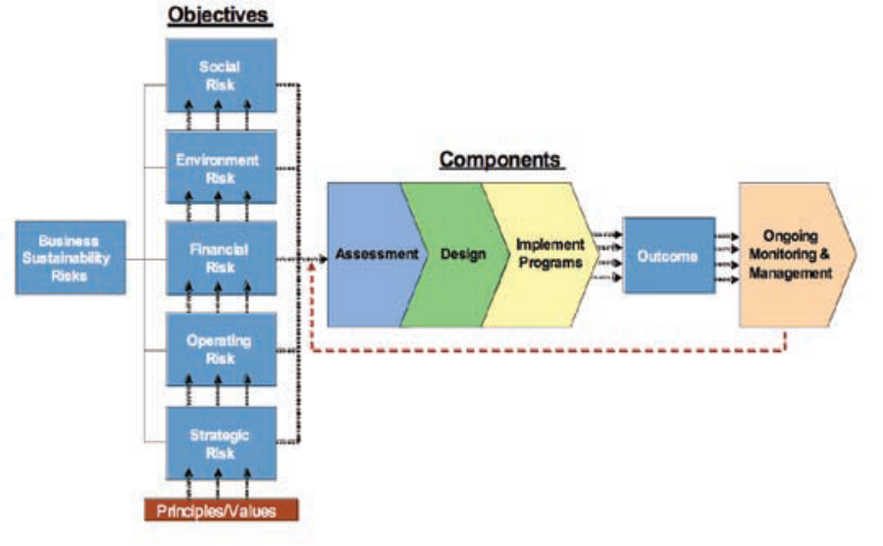

SIX PHASES OF SUSTAINABILITY

Phase 1: Rejection
- environment is regarded as exploitable
- hostility to environmental activities
- production and extraction processes destroy future & damage the ecosystem
- polluting by-products are discharged
- employees and sub-contractors are regarded as a resource to be used
- “lip service” to health and safety issues
- workforce compliance by threats/force
- almost no staff training
- minimal community concerns

Phase 2: Non-responsiveness
- ecological environment not considered as a relevant input
- financial and technological factors dominate business strategy
- efficiency rules
- environmental resources wasted and costs not considered
- training in technical area only
- wider social responsibility is ignored

Traditional ERM Framework

Phase 3: Compliance
- senior management see the need to comply with environmental laws
- attempt to limit liability of enterprise
- obvious environmental abuses eliminated
- employer seen as a decent employer
- regarding workplace standards
- organisation practises benevolent paternalism
- very few negative community issues addressed

Phase 4: Efficiency
- environmental practice seen as a cost
- review of environmental inputs and waste to minimise expenditure
- environmental issues that do not generate avoidable costs ignored
- ISO 14001 procedure may be in place
- coherent HR systems practised
- team work & training acknowledged
- funding of community projects with a positive return for the company

DUNPHY’S SIX PHASES OF SUSTAINABILITY

Dexter Dunphy and Jodie Benveniste of Sydney devised a way of quickly estimating where companies were regarding their sustainability or lack thereof. These 6 phases are identified as Rejection, Non-responsiveness, Compliance, Efficiency, Strategic sustainability, and Ideological commitment.

An overview of the six phases is given below

Ref: Benveniste is Sustainability: The corporate challenge of the 21st century (2000) Dunphy, D., Benveniste, J., Griffiths, A., Sutton, P. Allen & Unwin

Phase 5: Strategic Sustainability
- proactive environmental strategies seen as a strategic advantage
- product redesign to reuse or recycle
- environmental outputs are engineered to be useful
- leadership sought through being ‘environmentally friendly’
- workforce diversity sought and used
- social capital equals strategic advantage
- flexible workplace to maximise talent
- community-enterprise partnerships to address adverse impacts

Phase 6: Ideological Commitment
- actively promotes sustainability
- environmental best practice is espoused
- organisation thinks about sustainability throughout its entire operations
- organisation uses its influence with government to promote sustainability
- promoter of diversity & work/life balance
- has a corporate ethnical position and action plan for human welfare etc.
5 CORE ISSUES IN DETAIL

1. Economic Performance

• Sources & costs of corporate finance
• Profitability of operations
• Balance sheet (assets and liabilities), including changes over time
• Return on investment
• Cash flow and uses of cash
• Rating of corporate securities
• Capital expenditures (currently committed and planned for the future)
• Credit rating
• Insurance and risk management programs
• Ongoing Monitoring and Management

2. Environmental Performance

• Carbon footprint of the enterprise (CO2 and other greenhouse gas emissions)
• Raw materials used in manufacturing processes (and possible alternatives)
• Supplies used in manufacturing, packaging and shipping
• Energy requirements of operations including manufacturing, transportation and commuting employees
• Waste generation and disposal (including offsite disposal)
• Recycling, including capability of products and packaging to be recycled
• Historical uses of hazardous materials (legacy liabilities)
• Responsibility for historic pollution conditions and toxic tort claims
• Plans for expansion (domestic and international) and due diligence process
• Protection against accidental spills and releases
• Genetically modified products
• Discharges into streams or lakes
• Natural Resource Damage
• Emission of noise, odors and light
• Environmental compliance in all locations
• Ongoing Monitoring and Management

3. Social-Justice Performance

• Hiring and promotion practices, including equal consideration of minorities and women
• Anti-discrimination policies
• Sexual harassment training and prevention
• Training and education for employees
• Community outreach programs
• Charitable activities, including
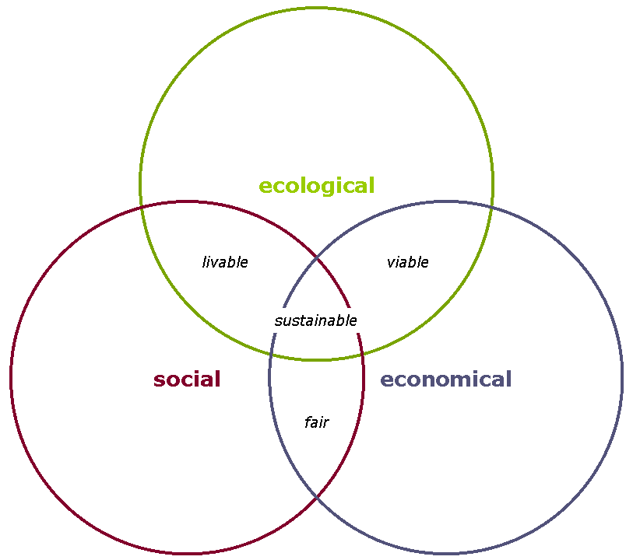
donations of time to community projects
• Family leave programs
• Safety of products
• Tax support of community and infrastructure
• Printed and electronic reports to stakeholders on financial, environmental and sustainable performance
• Advertising and other interfaces with customers and the public
• Engagement of stakeholders, including transparent public communications
• Employee health, medical, wellness

and retirement plans
• Rules that prohibit bribery and corrupt practices on a global basis
• Product quality and reliability
• Employee and consumer privacy
• Workplace violence response plan
• Ongoing Monitoring and Management

4. Operational Performance

• Manufacturing process, including flow charts and all physical movements
• Control of operations, including automatic systems and manual overrides for manufacturing processes
• Information gathering, data analysis and reporting of results, including use of data in refining operations
• Emergency response procedures
• Bottleneck analysis for critical operations
• Interdependency of operations and contingent risks for business interruption
• Supply chain review and consideration of alternative sources
• Protection against impact of external events, including storms, floods, earthquakes, etc. (not just insurance response)
• Employee retention and replacement programs
. Ongoing Monitoring and Management

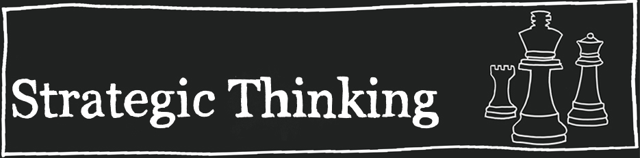
5. Strategic Performance

• Strategic planning, including product mix, markets and locations of operations
• Global expansion
• Potential mergers and acquisitions
• Prevention of unfriendly takeover
• Hiring and succession planning for key personnel
• Corporate governance, including qualifications and experience of senior management
• Composition and strength of the board
of directors
• Competition and competitiveness of products and services
• Ongoing Monitoring and Management

GETTING STARTED
5 Easy Steps
This is the simplest way to approach sustainability for any business

Step 1: Determine Point A

A sound starting point is to analyze where the business is today with regard to Dunphy’s 6 phases. Do a fully detailed analysis of the current state of the entire enterprise including all upstream and downstream touch-points. Knowing the full starting point is important. For example it may currently be at Phase 1 (rejection) or Phase 4 (efficiency) etc.

Step 2: Figure out Point B

Again, using Dunphy’s 6 phases, work out an ideal end point for the business, going forward. Many business strategists consider phase 5 ‘Strategic Sustainability to be a serious and valid goal.

Step 3: A Business Case may be required for justification purposes

Step 4: Conversion Plan

Analyze the difference between Point A and Point B so as to figure what needs to be changed to make the enterprise more sustainable. This may require a project-plan for the whole enterprise, or could be done on a unit by unit basis. It needs to include costs, timeframe, involvements etc.

Step 5: Monitoring System

A workable monitoring system can now be implemented to monitor all the activities in the business so as to maintain the sustainable state. By using this approach, no money is wasted, anyone can be included, and total visibility can be created for any interested party.

FINAL WORDS

Sustainability has many definitions and all are arguably correct in their own way. From the perspective of this paper, sustainability means ‘strategic business sustainability & risk management’. As such it addresses all known and assumed risks both positive and negative. This is done to achieve the best possible balance of outcomes for the economics of the business, the natural environment, and for all people who could be harmed by the full suite of activities associated with the business.

Original paper on ERM to SERM:
Sustainability – Beyond Risk Management (2007) www.aon.com

SS&RM Concept & Compilation
Ian R. Kirkwood PhD (2012)

